**May 2014 HL P1**

**Section A**

1. Identify **two** features that need to be considered when planning a new computing system for

an organization. [2]

1. Explain what is meant by beta testing. [2]
2. Describe **one** advantage and **one** disadvantage of using observations to gather information

when planning a new system. [4]

1. Outline **one** usability issue associated with the design of mobile devices. [2]
2. Distinguish between the use of **two** types of primary memory. [2]
3. Consider the following linked list which is maintained in alphabetical order.  
     
   With the aid of diagrams, explain how the node  
     
     
   would be inserted into the linked list. [3]
4. Outline how a colour can be represented in a computer. [2]
5. Identify **two** key features of a peer-to-peer (P2P) network. [2]
6. Outline the role of paging in the management of primary memory. [2]
7. Outline **two** distinct features of autonomous agents. [4]

**Section B**

1. A builder is renovating a series of apartments and is considering integrating a few electrical

devices in each apartment into an automatic programmable system. One example is the

integration of lighting, heating, ventilation and air conditioning.

1. Identify **two** groups of users that might find this integrated technology

particularly appealing. [2]

1. Discuss **two** advantages, offered by this technology, that could be used in an advertisement

for the apartments. [4]

1. Evaluate **two** ways users can access the functionality of the integrated system at home. [6]

The same technology is adapted and used for intensive chicken farming; in this context a  
 decentralized control is preferred.

1. Describe how this could be achieved. [3]
2. An international organization has offices located across several countries. For some of

its activities, for example human resource management, it has been decided to adopt a

“Software-as-a-Service” (SaaS) solution in order to keep the running costs low.

1. Describe the features of SaaS. [3]
2. Discuss the limitations of SaaS in relation to security. [6]

Each office makes some data available to external customers through the use of an extranet

and allows employees to work from home through a VPN.

1. Define the term extranet. [2]
2. Distinguish between a VPN and an extranet. [4]
3. The faceplate of a car stereo has six buttons for selecting one of six preferred radio stations.

As part of the internal representation of a microprocessor there is an array with six positions,

carrying the information about the radio frequencies, as follows.

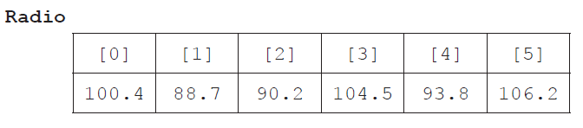

1. State the information at Radio[2]. [1]
2. Outline how a numerical frequency could be stored in a fixed-length string. [2]
3. Construct an algorithm in pseudocode that calculates the range of frequencies

(ie the difference between the highest and lowest frequencies) of any set of six selected

radio stations. [6]

The two-dimensional array Stats provides an indication of how often a specific station is

listened to by the user. For each button in the faceplate it records how often it has been clicked

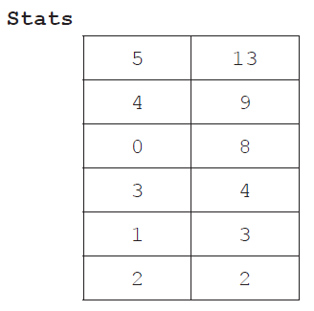 in the last 48 hours. Stats is ordered by the second column.

Both Radio and Stats are used by a procedure that allows the user to access the radio frequencies

that are listened to most often, as recorded in Stats, by flicking a lever on the steering wheel.

The frequencies are accessed cyclically, ie after the least used frequency the procedure returns

to the most used. For this reason a queue **Q** is used.

1. Construct an algorithm in pseudocode that, by using the structures Radio and Stats,

performs the following steps:

* it inserts the radio frequencies in the queue **Q**, following the actual order of preference;

and then

* it uses the queue **Q**, cyclically, to output an element each time the lever is flicked. [6]

1. Consider the following diagram and pseudocode for drawing on a display screen.

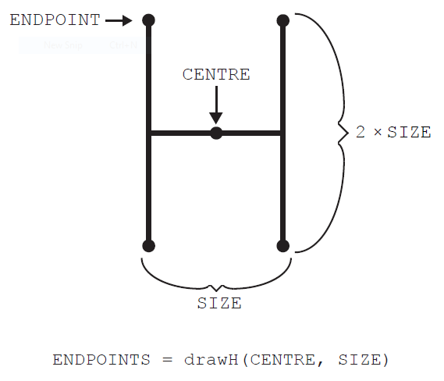

The method drawH(CENTRE, SIZE) will draw an “H” located at CENTRE with width of SIZE

and height of 2 × SIZE, as shown. It returns an array containing the four **endpoints** of the

vertical lines.

In the following flowchart, POINTS1 is a stack.

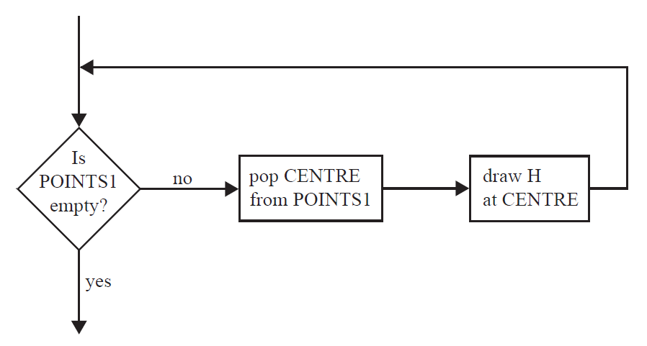

1. Construct pseudocode corresponding to the flowchart. [3]
2. Construct the drawing that would be produced by the flowchart on page 6 if it is preceded

by the following steps.

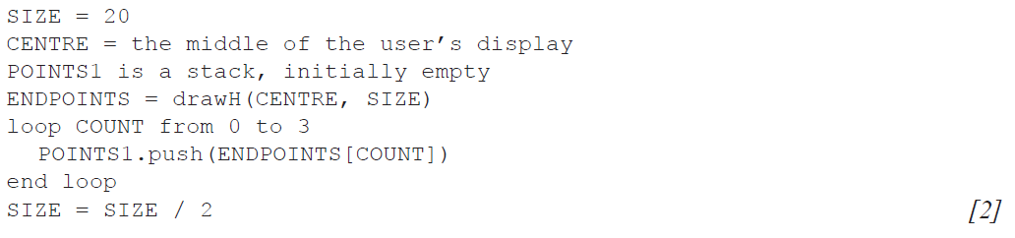

The pattern of drawing a new set of H’s, which have a SIZE value that is half the SIZE value

of the previous H, can be repeated. Each set of H’s of the same size is called a generation.

1. Construct an algorithm that will draw an initial H in the centre of the display and three

generations after that. [6]

1. State how many endpoints there will be after the initial H and three generations have been

drawn, without any consideration of the size. [1]

1. Suggest how drawing this pattern of H’s could be done recursively. [3]

1. A suburban railway system for a large city in Southern Europe consists of two lines **L1** and **L2**,

which meet at the station Centro, where passengers can change from one line to the other.

The system is shown below.

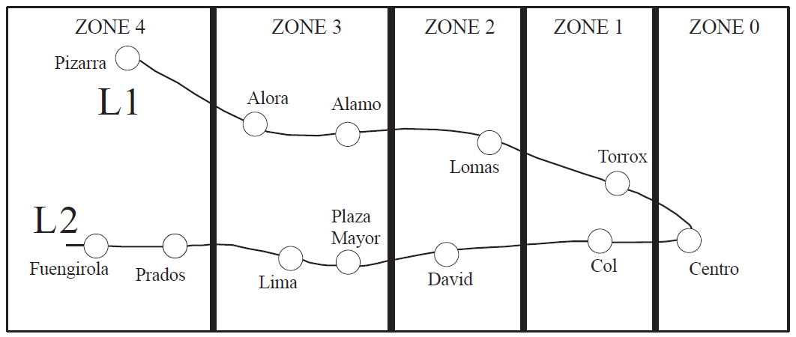

Each station is located in a particular zone, and the total number of zones in which the journey

takes place determines the train fare. Note, if a passenger starts in **Zone 1**, goes to **Zone 0** and

then back to **Zone 1**, the journey has taken place in **three** zones. Examples of the number of

zones are shown below for different journeys.

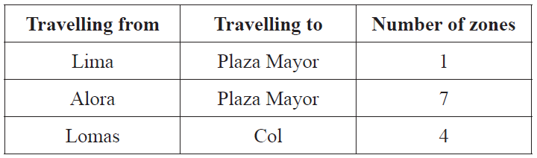

1. State the number of zones in which the journey takes place when travelling from Alora

to Fuengirola. [1]

The data for each station (station name, line, zone) is stored on the system’s server in the

collection TRAIN_DATA. There are 12 stations in total. The first part of the collection is

shown below.

Centro, L1, 0, Alora, L1, 3, Torrox, L1, 1, Col, L2, 1, ...

From this we can see that Alora is part of line L1 and is located in Zone 3.

At the start of each day, the data in TRAIN_DATA is read in to the binary tree TREE, in which

each node will hold the data for one station. The binary tree will be used to search for a specific

station’s name.

1. Sketch the binary tree after the station data from the first part of the collection,

given above, has been added. [3]

The TRAIN_DATA collection is also used to construct the one-dimensional array

STATIONS (which only contains the list of station names sorted into alphabetical order),

where STATIONS[0] = Alamo.

1. State the value of STATIONS[4]. [1]

The two data structures (STATIONS and TREE) are now used to construct the two‑dimensional

array FARES containing the fares between stations, partly shown below. Note that the fare for

travelling in each zone is €1.00.

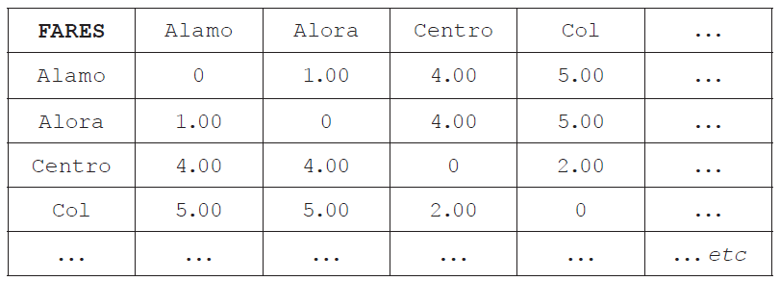

1. Calculate the fare for travelling from Torrox to Lima. [1]
2. Construct the algorithm that would calculate the fares for this two-dimensional array.

You can make use of the following two sub-procedures:

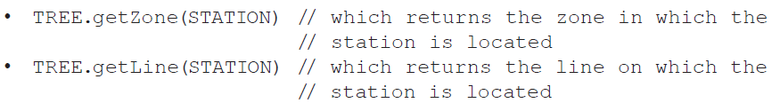

Your algorithm should make as few calculations as possible. [9]